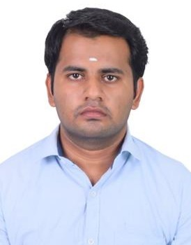ARUNPRASATH. C

**Address**: 65/1, Ujjisamy koil, 6th Cross Street, MDR Nagar, Aruppukottai Phone: 9788478787

Email Id: [arunchandra652@gmail.com](mailto:arunchandra652@gmail.com)

Adaptable professional with 2 years 9 months of work experience and proven knowledge of leadership, problem-solving, and work flow prioritization. Aiming to leverage my abilities to successfully fill the Engineer role at your company. Detailed-Oriented Professional with excellent communication, interpersonal and creative thinking skill. Aiming to Leverage my abilities to successfully fill the vacancy ay your company. Frequently praised as hard working as my peers, I can be relied upon to help your company achieve its goal. Hard worker experienced in problem-solving service and time management.

# Work Experience:

|  |  |
| --- | --- |
| **Sep 2020 – At Present** | **Seoyon E-Hwa Summit India Pvt Ltd Role:** Quality Line in Charge **Responsibilities:**   * Prepare and implementation of Check List. * Responsible for preparation of Inspection Test Plan (ITP) customer requirement. * Marked Items with Grade or Acceptance – Rejection Status, recommended necessary corrective action based on inspection result. * Adjusted, Clean and repair product and processing equipment to correct defects found during inspection. * Collected and selected sample for testing and for uses model * Discorded and rejected products material and equipment not meeting specification. * Update and Analyze of PPM Report. * Recorded Inspection and Test Data such as weights, Temperature, Grades and moisture content and quantities inspected and graded. |
| **June 2019- March 2020** | **Infac India Pvt Ltd Role:** Quality Line in Charge **Responsibilities:**   * Responsible for Preparing Quality Plan that supports the project and client’s requirement on quality control and quality assurance. * Visit Supplier to resolve Product Performance and Development Timing Concern. * Verified and Conformance to specification using measuring Instruments such as rulers, calibers, gauges and micrometers. * Recorded Inspection and Test Data, such as weights, Temperature, Grades and moisture content and quantities inspected and graded. * Compared colors, shapes and grades of products materials with   colored charts and sample to verified conformance to standards. |

**Other Activities:**

* Worked in two new projects in my company as NPD (New Product Development) managing assistant such as material maintenance, quality assurance, Product Guidance, Finished Product Approval.

# Skills:

|  |
| --- |
| * Lean Six Sigma |
| * 5S Principles |
| * AutoCAD 2017 2D&3D Drafting and Designing * CREO 7.0 (Basic Knowledge) |
| * Kaizen and Kanban |
| * Maintain PPE |
| * MS Office |

**Education:**

|  |  |  |
| --- | --- | --- |
| **2015-2019** | **Bachelor of Engineering: Mechanical Engineering**  Syed Ammal Engineering College, Ramanathapuram. | 62% |

# Language:

* + Tamil
  + English
  + Kannada (Speak)
  + Hindi (R/W)